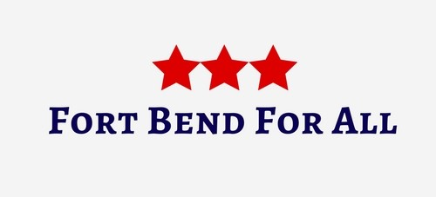

Minutes: Meet, Greet, and Plan!
Sunday, February 26, 2017

“Power concedes nothing without a demand. It never did and it never will.”
-Frederick Douglass

Welcome/Introductions
- We introduced ourselves and chatted as we ordered yummy Tex-Mex (with a crash cart on the side).
- We did an activity called, “What’s The Word?” Each of us wrote down one word (or two) that described our strengths and weaknesses. (see “What’s The Word?” handout).This will be used as we move forward so that everyone participates in the ways they feel most comfortable with.

History and Purpose of Group
- We talked about what led us to start Fort Bend For All and then about what the group’s mission will be. Our purpose is community outreach focusing solely on the disenfranchised and disadvantaged in Fort Bend County. Simultaneously, we will advocate for/against legislation affecting those we serve in the community and encourage engagement in government.

- We defined community outreach (see Group Plan - Advocacy Model handout). We discussed the importance of trying to register voters and to that end, the necessity of our becoming Volunteer Deputy Registrars. (see Voter Registrar handout)

- We outlined the areas we will serve to begin with, why those areas were chosen, and how we hope they will spread into other areas indicated. (see Group Plan - Geographical Areas handout)

Group Structure and Operation
- We talked about the “bones” of the group – communication (Facebook page, Twitter, website, group email, and member email list, (see Fundamentals handout)

- We decided that meetings will be twice per month to start – one in person and one online or via phone. We will have speakers and presentations at the in-person meetings. We hope to have someone from PennyWise Resale come speak to us about their operation and about the folks they serve. We are each going to clean out our closets and if we have things to donate, save them to take to PennyWise.

- The official governance of the group – by-laws, legal status (501c4), mission and vision statements will wait until the Legislative session ends in May).

Current Issues
- We discussed current issues of particular import to the county – immigration and discrimination. We looked at handouts pertaining to those subjects (attached to this document). We discussed the legislation and activities currently underway in those areas as well.

Action Plans
- Action plans for leaders:
- Jennifer is scheduling meeting with head of Fort Bend Social Services. (Ana. We actually got to meet her and talked about how we can support her candidacy for LCISD School Board.)
- Jaye is scheduling meeting with mayor of Stafford. We want to talk to him about how we can best serve that area.
- We will be attending VDR training.
- Liz is scheduling a meeting with Catholic Charities in Rosenberg.
- We will schedule a speaker for next meeting – TBA.
- Jaye is scheduling Fort Bend For All Day at Texas Legislature. Details will go out when we have them.
- Jaye and Jennifer will be digging deeper into a neighborhood of trailers damaged in the floods and if/how we can help.
- We will be scheduling a day for us to start walking through communities and interviewing residents.
- We will be investigating funding sources (grant) for an informational DVD project.

- Action plans for all:
- VDR training
- Disseminating Immigration Rights 101 and Anti-Muslim Discrimination sheets wherever you can.
- Continued calls to representatives regarding legislation (see Calls To Action on our page and/or call regarding those issues you care about)

